Motor Learning and Human Performance
Name
Institution

Human development integrates essential elements that define underlying characteristics regarding individual wellbeing. Individual traits are learned in different settings. The level of positive development is based on the need to create a highly engaged focus where it is possible to understand individual personality. Learning provides a useful knowledge of a better mechanism, which develops positive development among individuals. The decisions that are made are based on critical evaluation of the underlying concepts, which are integral in defining positive focus on fundamental developmental concepts. The different stages of human development play a key focus on the development of memory based on the underlying ideas, which create a highly diversified focus on better development elements. Motor learning has a critical influence on human performance considering that it is focused on skills gained through practice.
Motor learning and performance
According to Wulf and Lewthwaite,(2016), motor skills refers to permanent gains that are associated with specific skills that are learned. Thus, effective motor learning improves an individual vital skills which are essential in building a strong level of individual performance. Learning and memory are critical in the development of an individual, and thus the decisions that are made regarding a particular event are based on a focus on critical processes, which define positive change. Learning is a significant process, which focuses on identifying essential concepts, which represent positive change. It is necessary to ensure that a better understanding of underlying issues is effectively outlined to create a broader understanding of fundamental concepts which define positive change (Wulf & Lewthwaite, 2016).
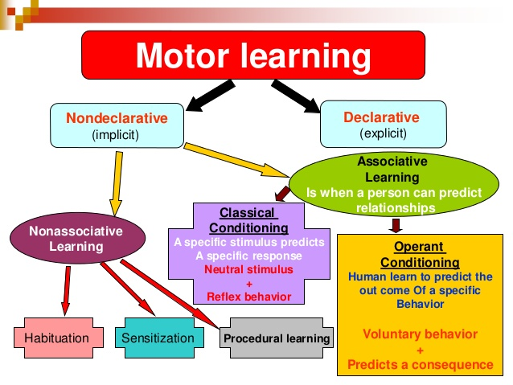
Source (Wulf & Lewthwaite, 2016).
Human performance is based on the underlying concepts that are learned. Therefore the learning concepts define a strong level of commitment where it is possible to focus on better elements that define positive development. Practice as integrated into this case focuses on the experience that an individual can gain after constant on same things creating an increased understanding and efficiency. Continued practice is aimed at ensuring that there is a better understanding of essential elements which define real knowledge on crucial issues that limit the ability to have a successful implementation process entirely (Payne & Isaacs, 2017).
Practice sharpens individual motor skills thus it is essential to have a clear understanding of how it plays a significant role in shaping personal development. Therefore, being an expert is based on having considerable knowledge of a particular issue, which can only be achieved through high experience due to increased interaction through continued practice. Making better decisions depends on the underlying ability to understand the existing complex concepts, which influence the level of expertise.
Learning through practice is very important and focuses on improving individual knowledge about specific concepts. It is essential to understand that through training, it is possible to understand the strengths and weaknesses of an individual. The identification of strengths and gaps help in implementing critical measures in practice to ensure that the deficiencies identified are controlled to improve individual expertise. Learning is a process that aims to provide that learners know given concepts. When an individual has a talent, there is a need to ensure that sharpen their skills to very active on what they can do. Therefore, learning through practice strengthens an individual ability to understand essential elements, which define a positive change in their lives, which has a positive influence on the underlying goals (Bahmani et al., 2017).
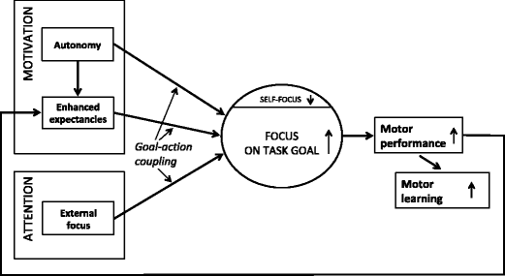
Source (Bahmani et al., 2014).

Cognition, behaviorism and performance
Grundey et al. (2017) assert that human performance is based on cognition and how they can perceive certain concepts that are being developed within a given learning environment. Cognition is a crucial process, which defines individual well-being through the integration of different practices through learning. The ability to integrate successful concepts within a given setting is essential in identifying an individual development. Cognitive psychology forms a crucial part of human development, and it integrates critical mental processes such as language use, memory, perception, attention, problem-solving, critical thinking, creativity and problem-solving. The ability to effectively incorporate these concepts defines an integral focus on critical processes that determine a positive individual development (Grundey et al., 2017).
Comprehension is an essential cognitive development aspect, which shape and individual wellbeing based on the underlying learning concepts, which define necessary outcomes. Therefore, the ability to extract meaning from statements is crucial cognitive skill, which allows an individual to focus on crucial elements that have a positive influence on individual development. Learning is a process, which provides an integral focus on critical concepts, which define personal growth. Therefore, essential ideas that are evaluated in this case include learning and memory. Having a better knowledge and interpretation of a given aspect is necessary for defining a different consideration of crucial elements that define positive engagement where it is easier to determine the influence of concepts (Ganesh et al., 2014).
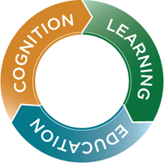
Source: Washington University
Learning provides a useful knowledge of a better mechanism, which develops positive development among individuals. The decisions that are made are based on critical evaluation of the underlying notions, which are integral in defining a definite focus on fundamental developmental ideas. The different stages of human development play a key focus on the development of memory based on the underlying concepts, which create a highly diversified focus on better development elements. It is critical to ensure that the essential aspects that are integrated within the system provide developmental ideas that define a successful focus on details that define a successful individual development (Payne & Isaacs, 2017).
Human development involves the ability to learn new things where there is an equal chance for individuals to learn new things, which characterize the drive. Therefore, an individual is motivated by the fear of being left behind and thus develops new learning mechanisms, which are vital for the next stage in the developmental process. If the dominant response in a given hierarchy results in a reduction of the urge or drive, then reinforcement is likely to occur. Reinforcement is the strengthening of the existing relationship between the different players within a learning process.
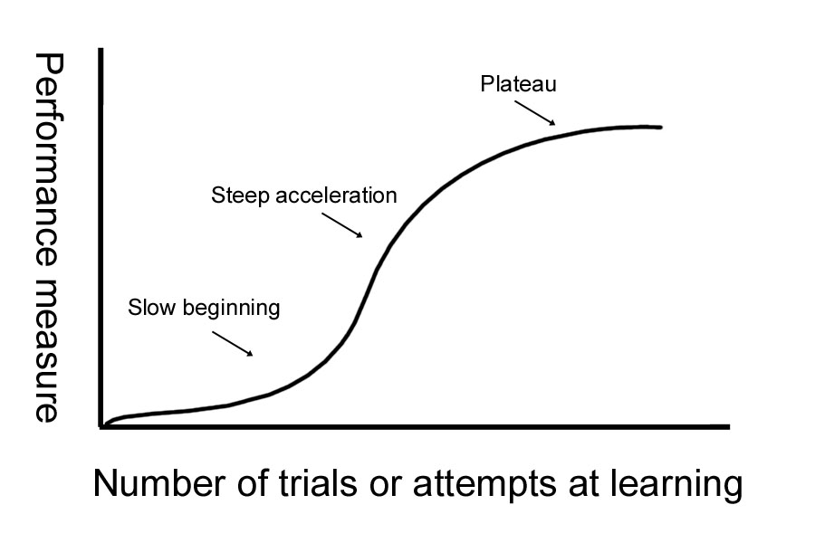
Source (Lemos et al., 2017).
The graph above provides an understanding of the relationship between performance and learning. Individual learning has a crucial influence on critical factors that define positive change. The integration of these factors outlines better concepts that define individual development and performance.
Behaviorism thus considers techniques, which help in understanding human behavior. The behavior that an individual adapts plays a considerable role in influencing their overall social environment. Understanding individual behavior is vital in getting to understand some of the crucial aspects, which help in understanding the varied reactions that individuals have. There are many issues, which tend to influence human behavior, the different challenges are critical in creating a diverse environment where it is not easy to understand why individuals behave in a certain way (Lemos et al., 2017).

Conclusion
Motor learning has a critical influence on human performance based on the underlying traits that define positive change. Understanding the motor skills that define individual wellbeing help understand better elements that define better concepts that need to be incorporated into an individual performance to achieve the underlying personal and professional goals. Having a clear plan enables an individual to integrate necessary measures that promote motor learning combines, cognition and behavioral concepts which define an individual character and the ability to perform based on the underlying performance standards.

References
Bahmani, M., Wulf, G., Ghadiri, F., Karimi, S., & Lewthwaite, R. (2017). Enhancing performance expectancies through visual illusions facilitates motor learning in children. Human movement science, 55, 1-7.
Ganesh, G., Takagi, A., Osu, R., Yoshioka, T., Kawato, M., & Burdet, E. (2014). Two is better than one: Physical interactions improve motor performance in humans. Scientific reports, 4, 3824.
Grundey, J., Amu, R., Batsikadze, G., Paulus, W., & Nitsche, M. A. (2017). Diverging effects of nicotine on motor learning performance: improvement in deprived smokers and attenuation in non-smokers. Addictive behaviors, 74, 90-97.
Lemos, A., Wulf, G., Lewthwaite, R., & Chiviacowsky, S. (2017). Autonomy support enhances performance expectancies, positive affect, and motor learning. Psychology of Sport and Exercise, 31, 28-34.
Payne, V. G., & Isaacs, L. D. (2017). Human motor development: A lifespan approach. Routledge.
Wulf, G., & Lewthwaite, R. (2016). Optimizing performance through intrinsic motivation and attention for learning: The OPTIMAL theory of motor learning. Psychonomic Bulletin & Review, 23(5), 1382-1414.

